Please fill in this form carefully and completely. **Incomplete forms will not be accepted.**

Read the instructions before completing the form!

The template as well as all related documents must be submitted **at least two weeks** before publishing date!

**Short-notice submissions will not be accepted.**

|  |  |  |
| --- | --- | --- |
|  | Author/Submitter | Click or tap here to enter text |
|  | **Invoicing contact** (name and full/e-mail address) | ***Mandatory!***  Click or tap here to enter text |
|  | Desired publishing date | Click or tap to enter a date |
| **1** | **Sender name** | ***Mandatory!*** *E.g. AOTrauma Middle East and Northern Africa*  Click or tap here to enter text |
| **2** | **Sender's e-mail address** | ***Mandatory!*** *E.g. courses@aotrauma.org*  Enter e-mail address |
| **3** | **Subject line** | ***Mandatory! Short text with call to action****. E.g. "Book your seat now for the congress xy"*  Click or tap here to enter text |
| **4** | **Reply-to e-mail address** (can be identical to sender’s e-mail address | ***Mandatory!*** *Who will be answering questions? E.g. course organizer's e-mail address*  Enter e-mail address |
| **5** | **Preheader message** | ***Mandatory! Short text (4–6 words) with call to action****. E.g. "Book your seat now for the congress xy"*  Click or tap here to enter text |
| **6** | **Title** | *Optional.* ***Keep it short!*** *Max two lines. E.g. course title, or topic of the e-mail.*  Click or tap here to enter text |
| **7** | **Subtitle** | *Optional. E.g. Your unique learning opportunity this summer. Or: the only Basic Principles Course in the region.*  Click or tap here to enter text |
| **8** | **USP/key message** | ***Mandatory!*** *Why is it relevant? Why should recipient read the e-mail? E.g. Famous course chair, special course format (describe), only course in the region*  Click or tap here to enter text |
| **9** | **Call to action** | ***What is the recipient supposed to do?*** *E.g. submit application, register now, become excellent, support improvements, we need your opinion, apply now, help improving, learn more, book your seat*  Click or tap here to enter text |
| **10** | **Body** | ***Answer these questions in your copy: What? / Who? / Why?*** *Provide sufficient and relevant information according to the e-mail format you use.*  Click or tap here to enter text |
|  | **Links** | *If not included in body text*  Click or tap here to enter text |
| **11** | **Picture** | ***Every picture must be submitted as a separate file (original size, if possible)!*** *Best format is JPG*  Picture available in best available quality |
|  | **Target group/s** | Global: members and users  Global: members only  Regional: members and users  ESA;  MENA;  AP;  LA;  NA  Regional: members only  ESA;  MENA;  AP;  LA;  NA  Additional recipients: Enter e-mail addresses  Others: Please specify, e.g. country |
|  | Additional publishing types | Website news story  Social media post  Others: Please specify |
|  | Expected costs | Lumpsum per e-blast: CHF 400.00  Picture search / simple editing: CHF 60.00/image  Picture license (if needed): CHF 15.00/image  Additional correction rounds: CHF 30.00/round of edits  More complex picture editing: at cost |
|  |  | Total (expected): CHF ____ |

**Answering these questions will make your e-blast more relevant to your recipients!**

|  |  |
| --- | --- |
| **WHAT?** | ***What***do you want to tell? You need to stand out from the crowd of information. You do not want to be perceived as just another advertising e-mail. What kind of information would you like to receive yourself? **Provide valuable and RELEVANT information to your audience!** |
| **WHO?** | **You need to understand your audience** – your users and your potential members. Think of their interests and their needs. The better you know ***who***they are, the better you can deliver valuable information. |
| **WHY?** | You should give the reader an idea of ***why***your story is **newsworthy and relevant** to write and share with the rest of the community. |
| **WHEN?** | Think of the best time to deliver your information to your audience. Think of their daily routine. ***When*** *are they online, when*would they want to read your communication? |
| **Quotes** | A good quote can be the heart of a **compelling** news/article/e-mail. Good quotes help to tell a story and enhance its credibility. |

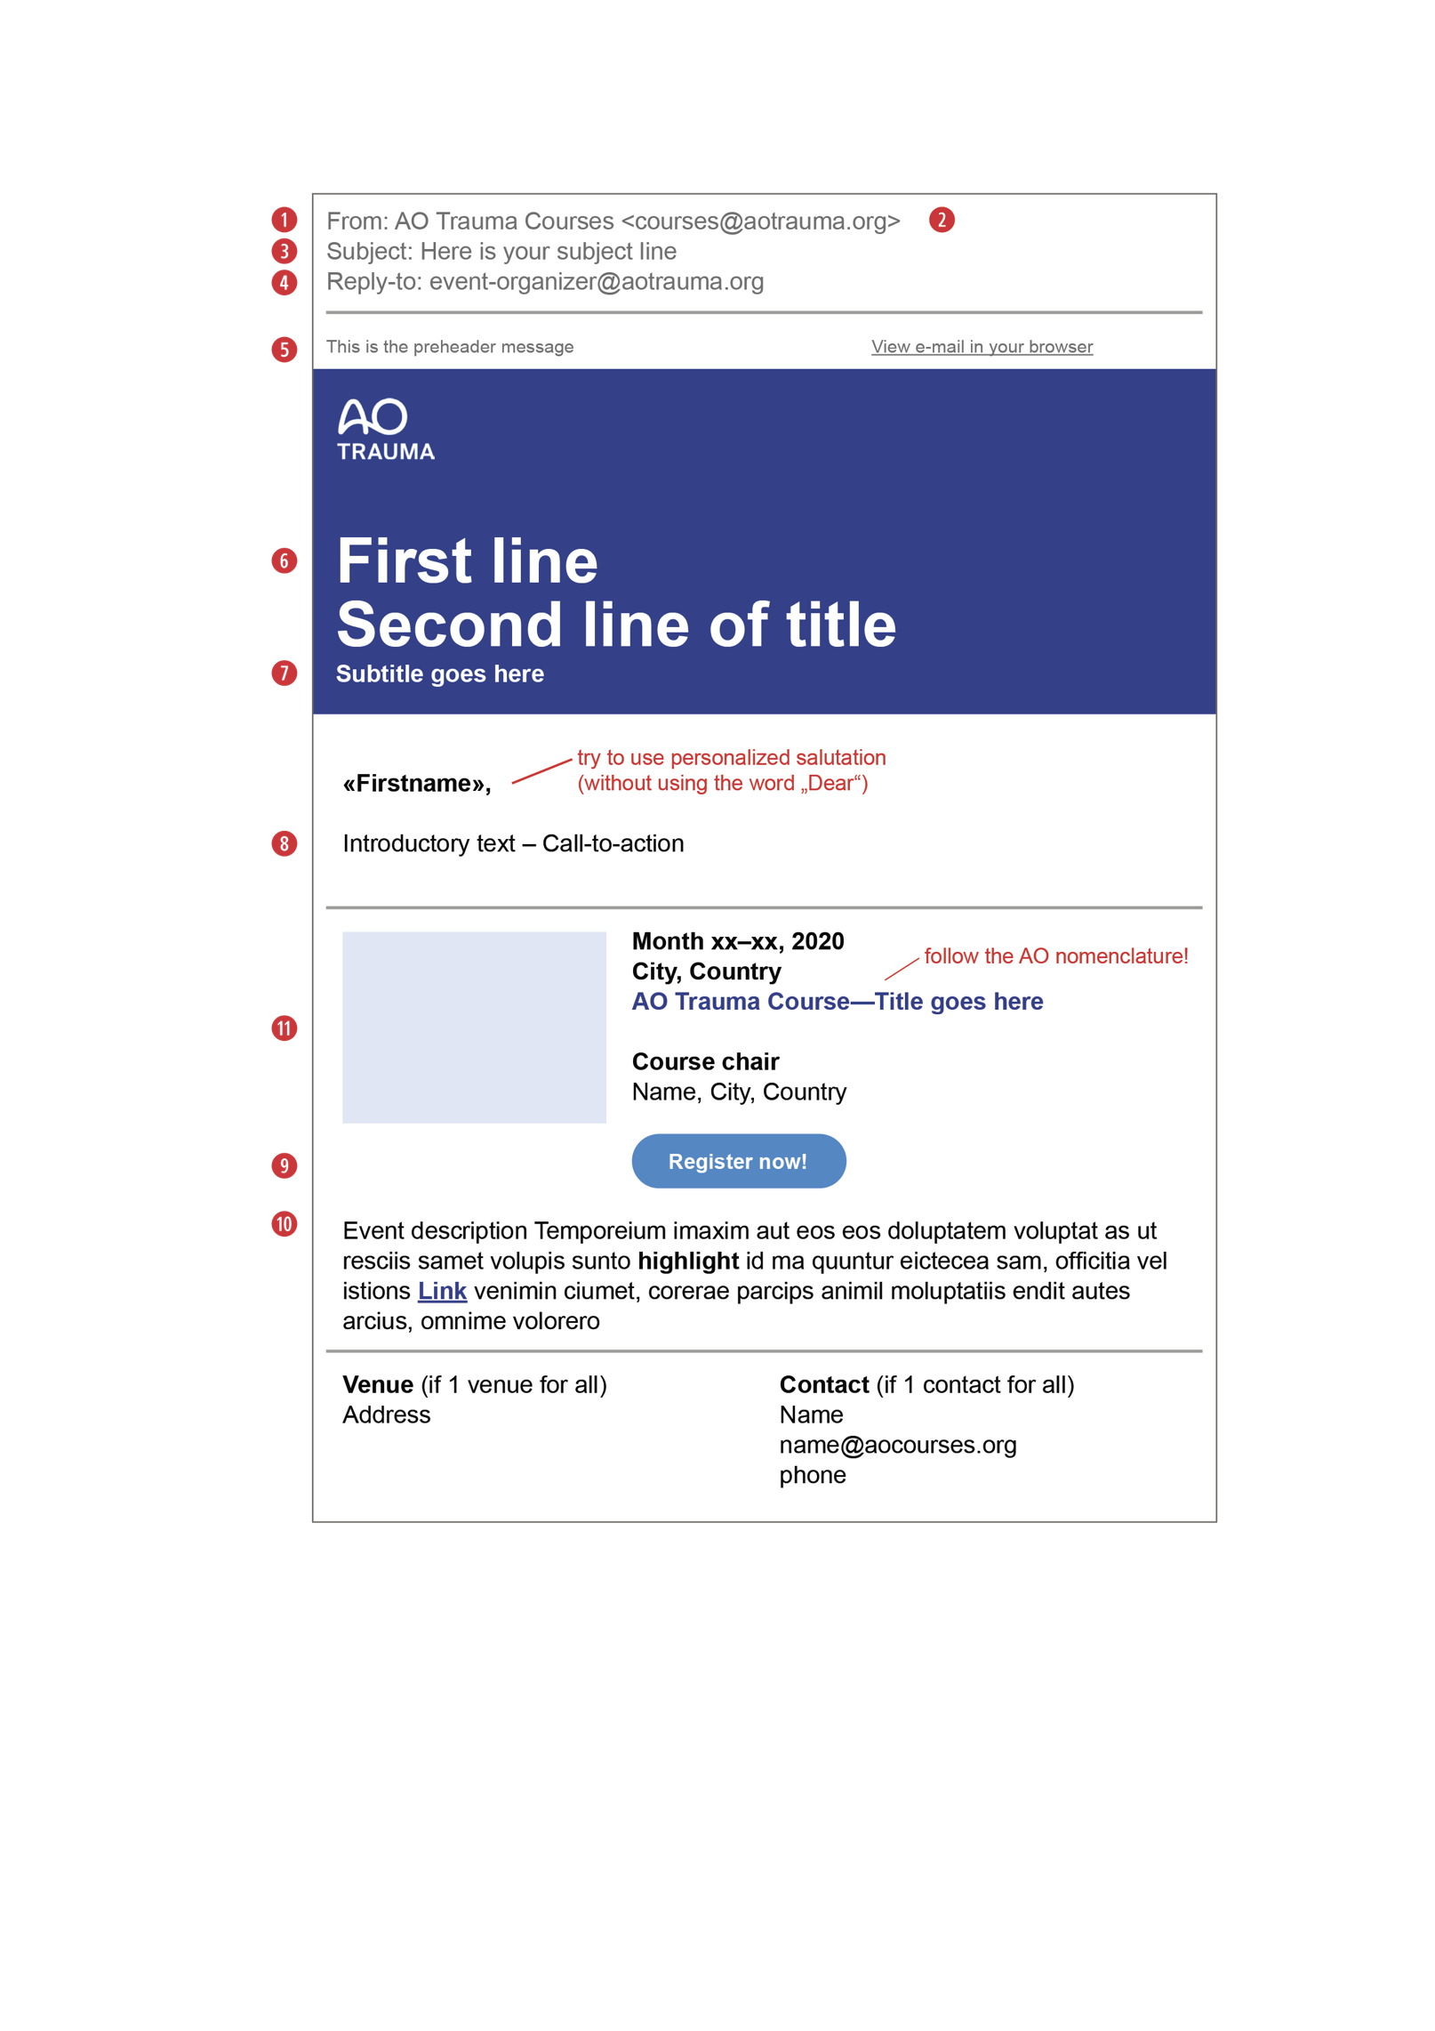All modules in this sample are   
mandatory, but the layout is   
subject to changes, in order   
to best reflect the needs   
and the content.

The numbers (1–11) are reflected   
and explained in the table above.

The “First line” title can be the  
Call-to-action with or without   
a link (eg to the event registration).

